***Challenges and Future Opportunities of Hairpin Technologies***

1. Power requirements and contributes

Due to the conversion to electric for mechanical, hydraulic and pneumatic systems in automotive, marine and aerospace industries, the new challenges in power generation deal with an increment of power limitation. To satisfy the higher power density requirements from electric motors, the elements that must be taken into account are: torque, speed and winding technologies. Table 1 summarizes the main contributes to improve these aspects with power density increment.

Table 1 Main contributes to increase Power density in Electric Motors

|  |  |  |
| --- | --- | --- |
| **Power density** | **Torque** | **Speed** |
| * Air gap flux density   properties of materials   * Linear current density   systems and improved thermal management   * Operating conditions   E.g. optimal control | * Mechanical properties of materials * Optimal machine design * Parasitic effects   E.g. compensation for skin effect, increased reliability |
| * **Winding technologies** * Decrease winding resistance, e.g. through larger wire diameters, reduced end winding lengths * Decrease AC parasitic effects * **Increase fill factor** | |

1. Fill factor increment: Hairpin solution

In order to increase power density, it is reasonable to fulfil slots with a larger amount of conductor area, i.e. conductor’s fill factor. Different solutions concerning this contribute has been taken into account: segmented stator, pressed coils etc. Replacing round conductors with rectangular conductors, the slots are matched in shape. In Figure 1, Hairpin technology represents the rectangular conductor solution allowing the fulfilment of the area with conductive material.

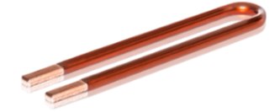

Figure 1 Hairpin conductor

1. Hairpin Manufactory process

A preparatory phase divided in straightening, stripping and cutting of a rectangular conductor is completed. The manufactory process start with shaping of the conductor into hairpin form. Once the conductors are obtained, the stator’s slots are fulfilled during assembly phase. After this, twisting phase is performed to deform all hairpins simultaneously obtaining the desired structure of conductors for stator. Finally, contacting completes the process. About this last phase, Laser welding is the technique applied for mass production as it ensures high quality contacts, low cycle time and an automatized process. For prototyping, soldering is exploited for costs reduction. Sizing of conductors is defined in standard IEC60317-0-2 with recommended width and thickness ratio depending on insulator grade.

1. Future Opportunities with Hairpin

Simulations with FEM show the current density distribution in slot and magnetic field lines. In Figure 2 it is possible to observe current displacement along radial direction of stator due to skin and proximity effects reducing effective conductive area in slots.

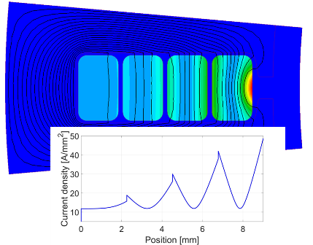

Figure 2 Classic hairpin in slots and relative current density

In order to reduce these drawbacks, two new structures have been studied: asymmetric and segmented. In the former, height reduction of conductors across the slot (smallest hairpin near to the slot opening) reduces current density peaks as shown in Figure 3.

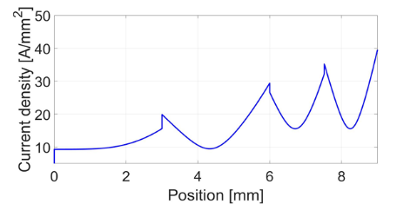

Figure 3 Asymmetric Hairpin current distribution in slot

Improving homogeneous current distribution, segmented solution consists in design 2 or more parallel paths for conductors near the slot opening as in Figure 4.

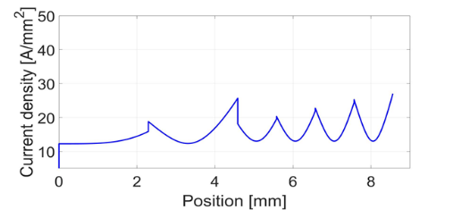

Figure 4 Segmented Hairpins current distribution in slot

Finally, both solutions allow to reduce current losses and so thermal losses too.